Ecology node 7.504455,4.528492

Quarters node 7.532312,4.537860

Senate node 7.518769,4.523483

White house gateway 7.516377,4.530935

White house node

7519683,4.520058

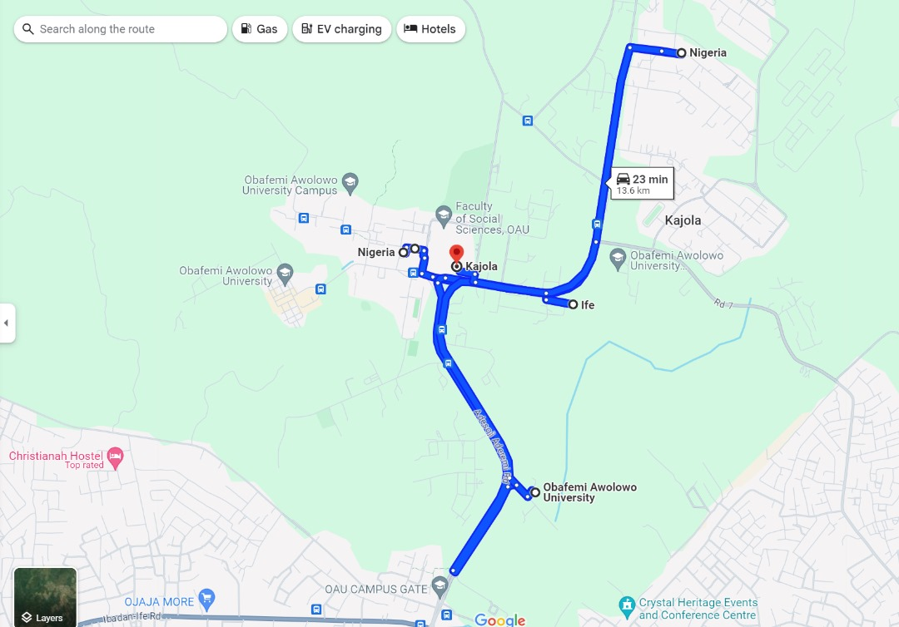

Opa dam 7.504455,4.528492

White house node 7519683.4.520058

White house gateway 7.516377,4.530935

Senate node 7.518769,4.523483

Ecology node 7.504455,4.528492

Opa dam 7.504455,4.528492

Quarters node 7.532312,4.537860